PROFIT AND LOSS ACCOUNT

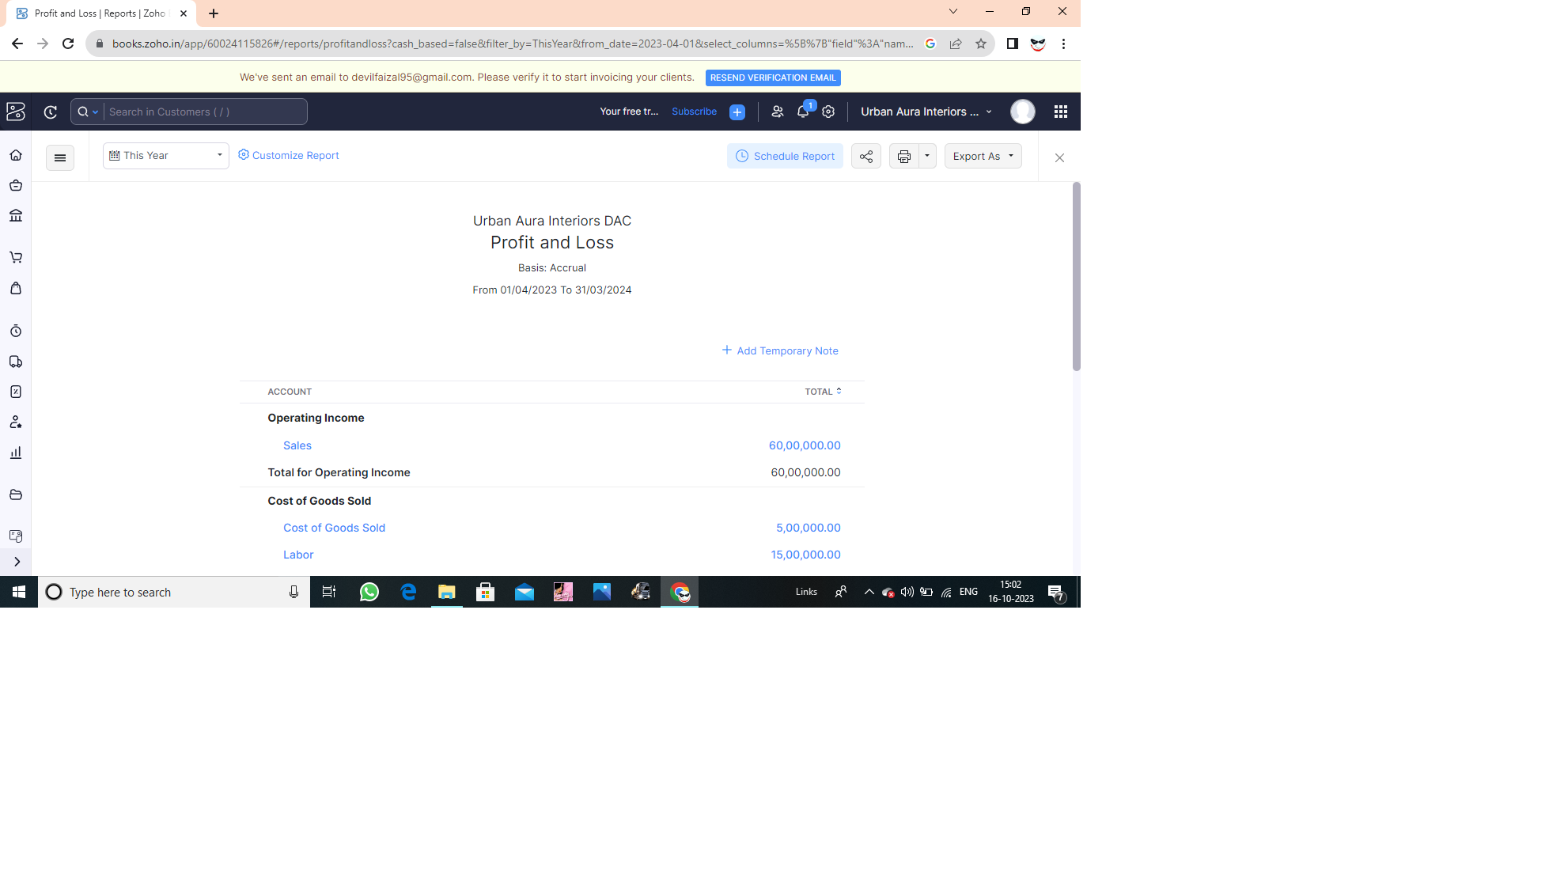

BALANCE SHEET

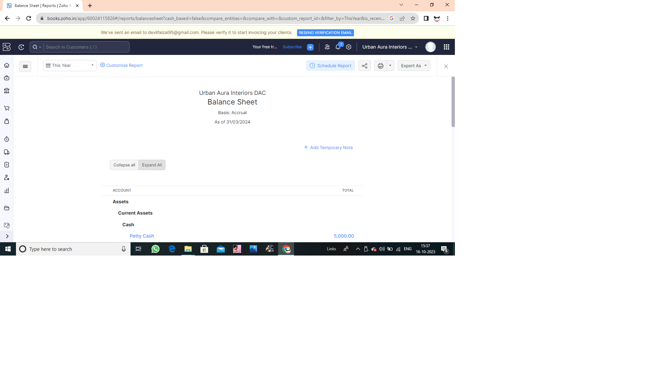

GST REPORTS

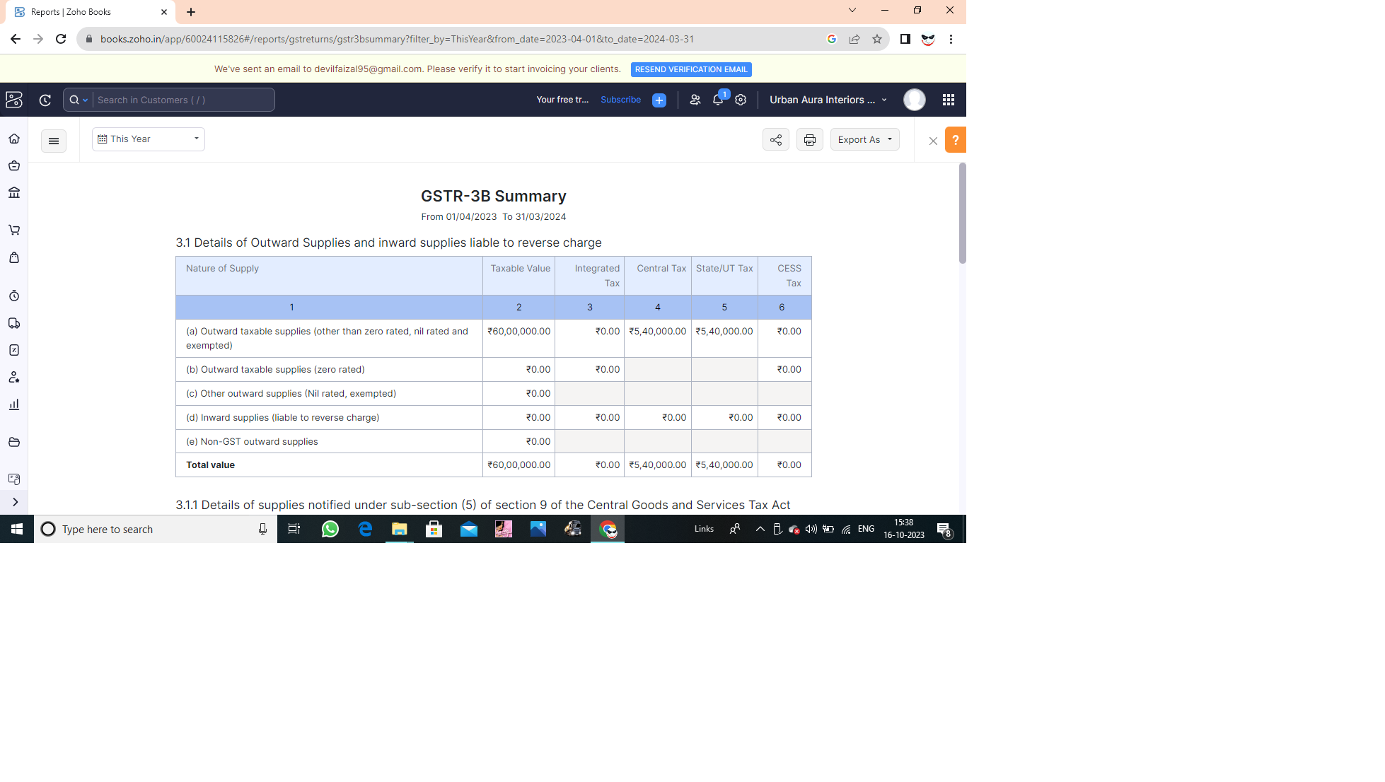

TAX RETURN

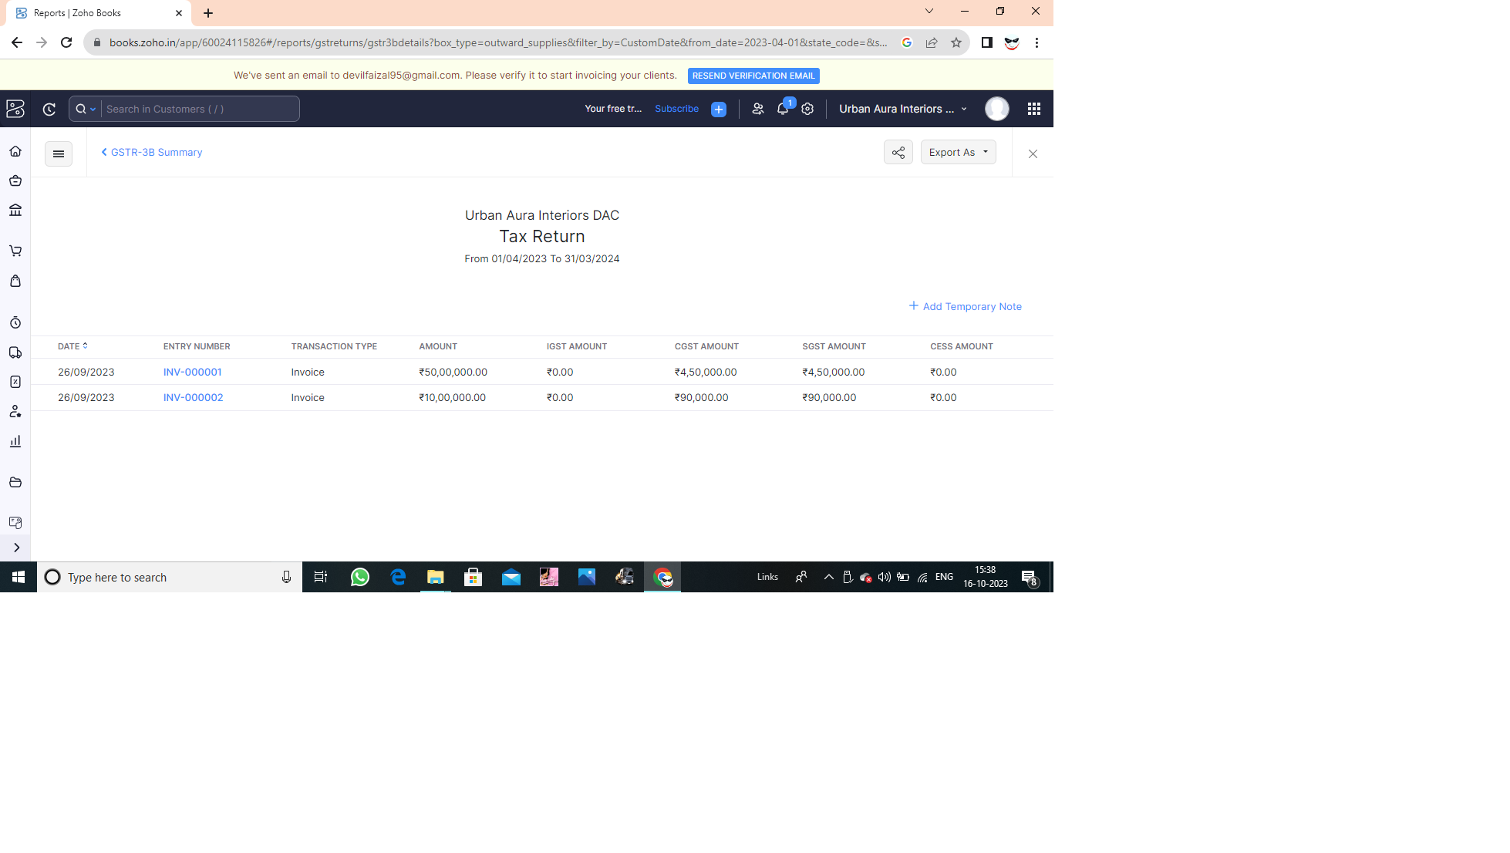

JOURNAL REPORT

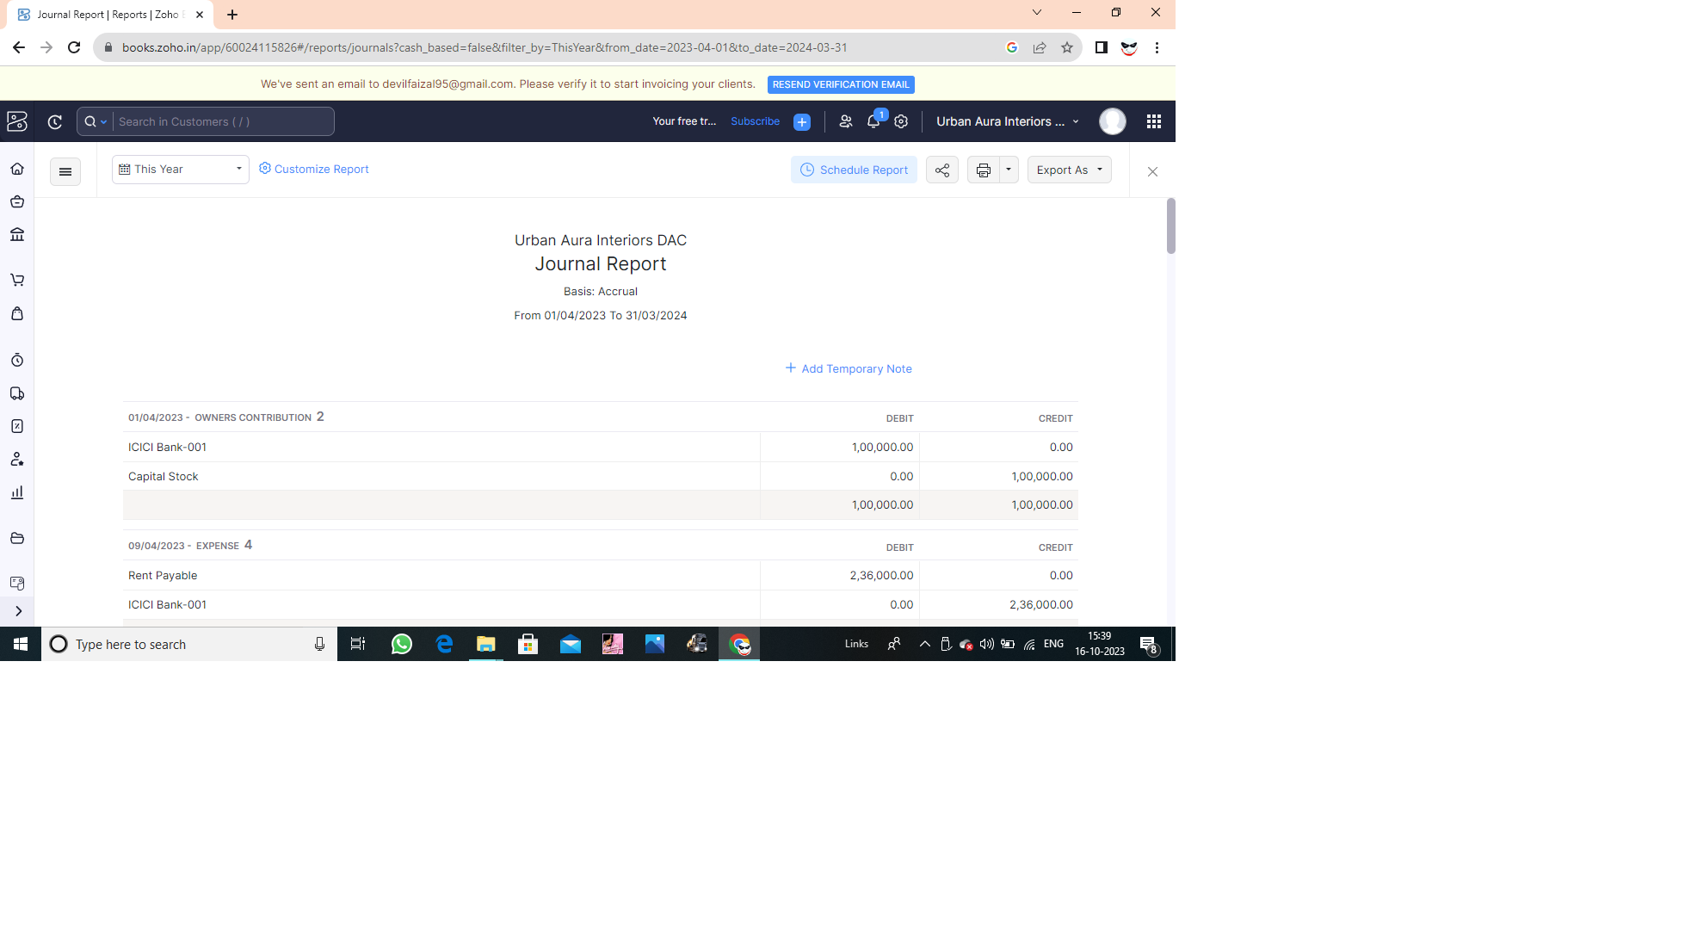

ACCOUNTS RECEIVABLE AGING DETAILS

AR SUMMARY

